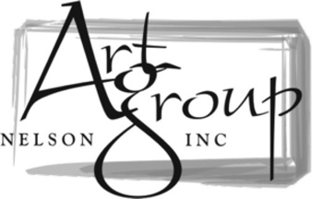

MEMBERSHIP FORM
Annual Membership from 1st April to 31st March.

NAME: ____________________________________________________

ADDRESS: ____________________________________________________

____________________________________________________

POSTAL CODE ____________________________________________________

PHONE: ____________________________________________________

EMAIL: ____________________________________________________

*OPTIONAL - Your preferred medium(s):

PAYMENT:
$30 to become a member, renewing every 1st April at $30 per year.
Direct bank transfer your payment to “Art Group Nelson” Westpac 03 0703 0490878 00 with ‘Subs’ and your name as reference.
Email this form to Robbie at robbieandanita@iconz.co.nz and let us know you have paid.

Check out our website for newsletters, workshops, info on the upcoming monthly meetings, and more. https://www.artgroupnelson.org.nz/

You can also join our Facebook page or follow us on Instagram to get up to date information about the group, as well as what’s happening in the art community in Nelson.
https://www.facebook.com/artgroupnelson
https://www.instagram.com/artgroupnelson/

