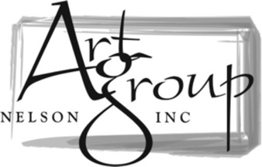

MEMBERSHIP FORM
Annual Membership from 1st April to 31st March.

NAME: ____________________________________________________

ADDRESS: ____________________________________________________

____________________________________________________

____________________________________________________

PHONE: ____________________________________________________

EMAIL: ____________________________________________________

*OPTIONAL - Your preferred medium(s):

PAYMENT:
$30 per year (single) or $40 (double – same household)
Direct bank transfer your payment to “Art Group Nelson” Westpac 03 0703 0490878 00 with ‘Subs’ and your name as reference.
Email Robbie at robbieandanita@iconz.co.nz to let us know you have paid.

********

Check out our website for newsletters, workshops, info on the upcoming monthly meetings, and more. https://www.artgroupnelson.org.nz/

You can also join our Facebook page to get up to date information about the group, as well as what’s happening in the art community in Nelson. https://www.facebook.com/artgroupnelson

