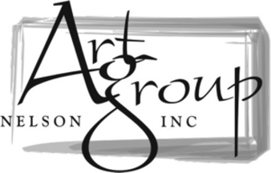

**MEMBERSHIP FORM**

Annual Membership from 1st April to 31st March.

**NAME:** ____________________________________________________

**ADDRESS:** ____________________________________________________

____________________________________________________

**POSTAL CODE** ____________________________________________________

**PHONE:** ____________________________________________________

**EMAIL:** ____________________________________________________

**PAYMENT METHOD:** CASH __________ Bank Transfer _____________

**\*OPTIONAL - Your preferred medium(s):**

**PAYMENT:**

$30 to become a member, renewing every 1st April at $30 per year.

NOTE: Membership fees will increase to $35 from April 2025.

**IN PERSON:** Come to a club meeting (1st Wed of the month @ 7pm at Greenmeadows Community Center) and fill in the membership form and pay cash.

**JOIN ONLINE:** Direct bank transfer your payment to “Art Group Nelson” Westpac 03 0703 0490878 00 with ‘Subs’ and your name as reference. Then Email this form to [artgroupnelson@gmail.com](mailto:artgroupnelson@gmail.com) and let us know you have paid.

Check out our website, Facebook or Instagram for newsletters, workshops, info on the upcoming monthly meetings, and more.

https://www.artgroupnelson.org.nz/

<https://www.facebook.com/artgroupnelson>

<https://www.instagram.com/artgroupnelson/>